## **Configuring IP address to Routers in Packet Tracer and configuring static routes in multiple router topology**

* A topology was created using three Router-PT and two PC's connected to two routers using copper cross-over connections and serial DCE connections
* Different default gateways were configured for both the PC's .
* A unique IP address was configured for each PC.
* IP address was configured for each interface using CLI
* Pinging PC1 from PC0 gave destination host unreachable
* ip routes for each router was viewed using the command: show ip route
* Static ip route was configured for each router using CLI commands: ip route destination_network subnet_mask next_hop_address
* Pinging PC0 from PC1 and PC1 from PC0 gave the required ping responses

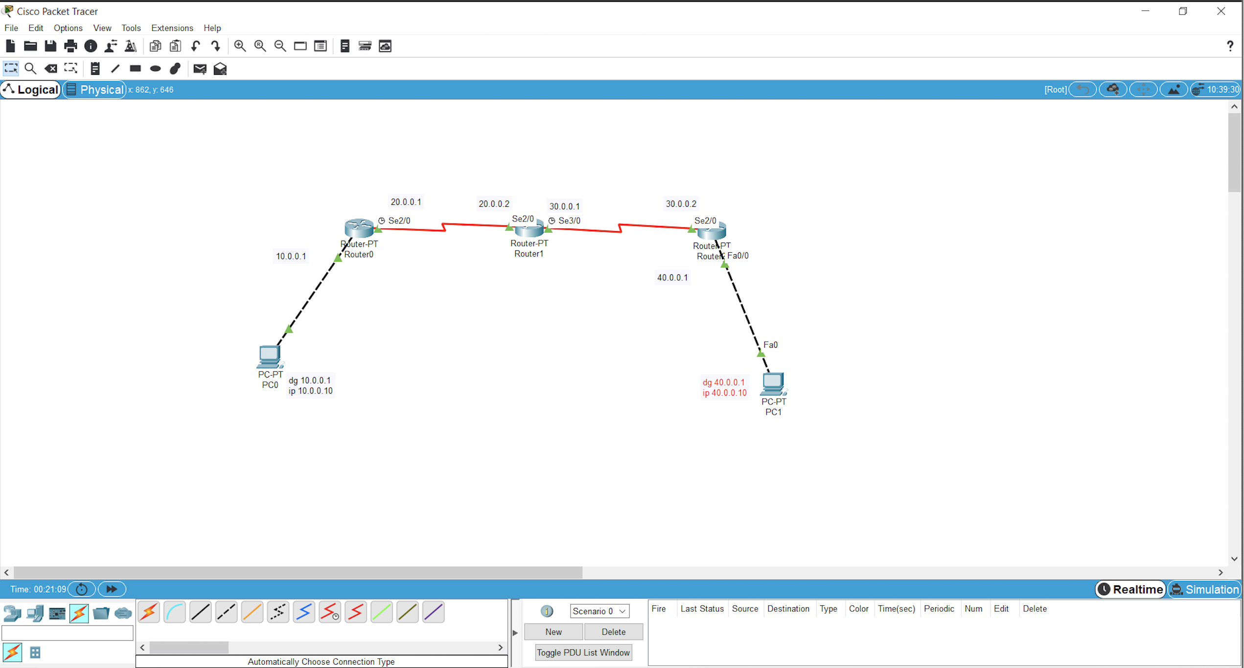

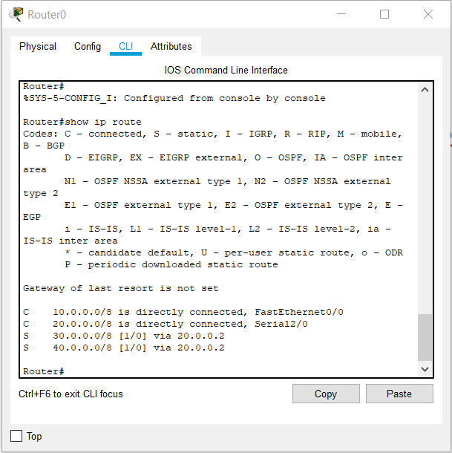

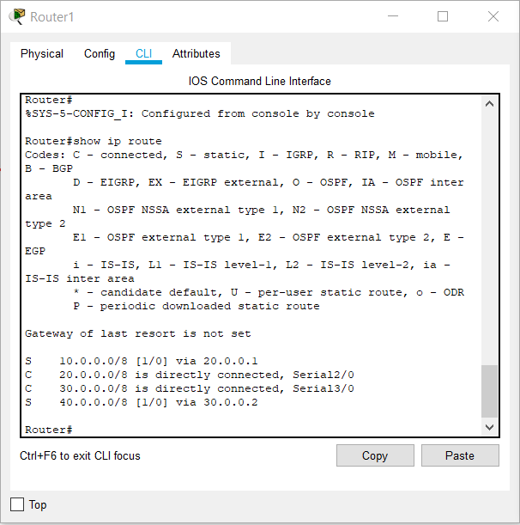

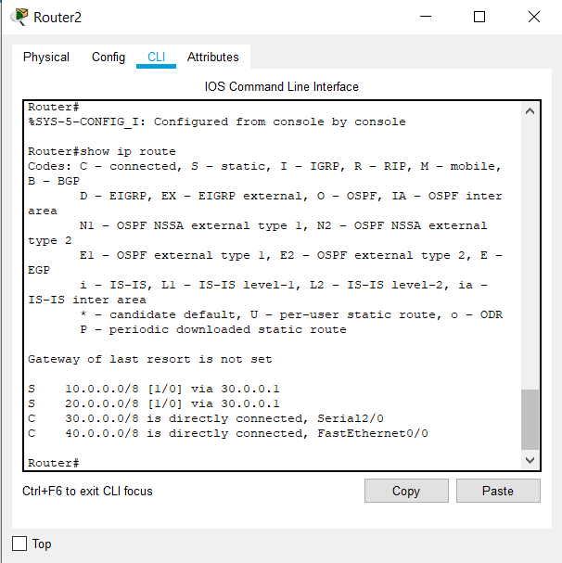

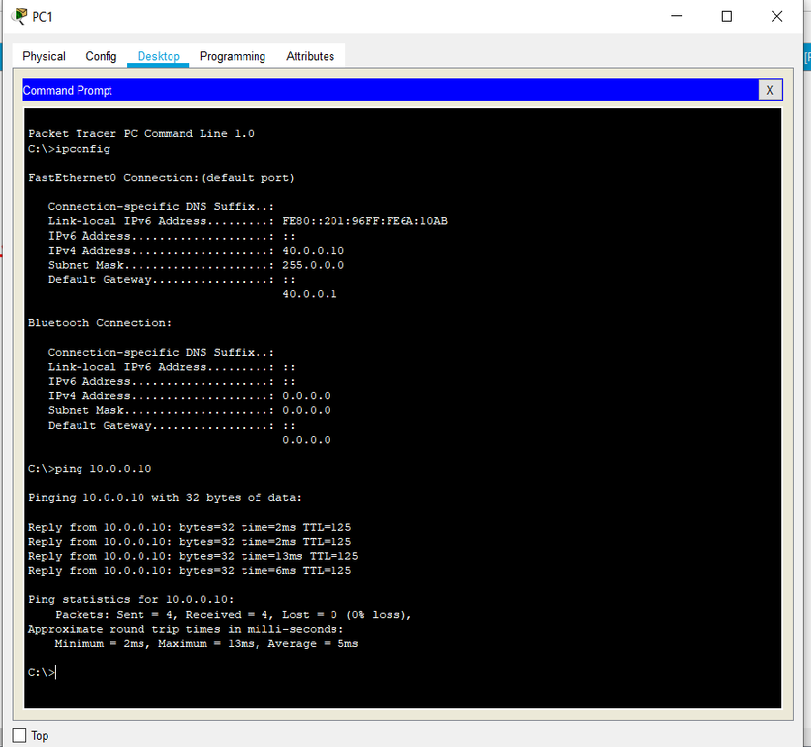

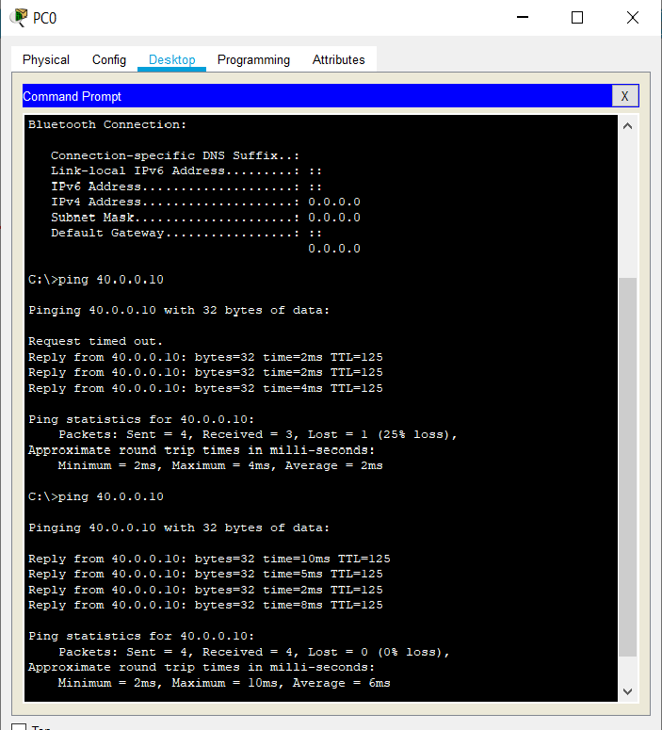

### Learning Outcomes

* Creating a topology with multiple routers.
* Configuring default gateway and ip address.
* Configuring ip address for the interfaces
* Pinging gives destination host unreachable if the device networks are not directly connected
* Configuring static ip routes
* On configuring the static ip routes, pinging gives the required response